Green Society Public School
D-18
Ratnanagar-7, Sauraha, Chitwan
Third Terminal Examination-2082
Class: Nursery Time: - 2 hrs. F.M.: 50
Sub: English ‘W’
Name: Roll No.: Sec.:
________________ ______________ OBT.MARKS:
INVIGILATOR EXAMINER

1. Match the letters with the correct pictures. [8]
A
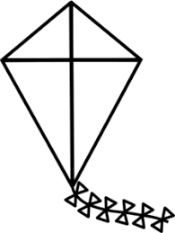
F

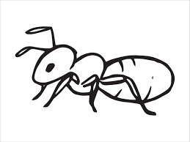
I

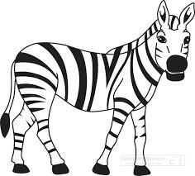
K

S
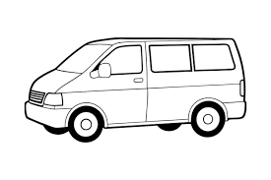
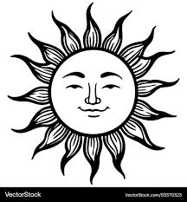
O

V
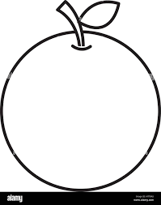
Z

2. Circle the letter of 'M'.
M
A O N
M M M
P A L
M M

3. Copy the same letters. [5]
H I J K
___ ___ ___ ___

L M N O
___ ___ ___ ___
4. Match the same capital and small letters. [6]
R t
T r
H e
E h
W z
Z w

5. Write (Qq to Zz). [10]


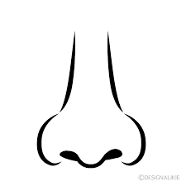
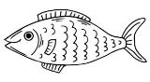

6. Write the first letters of given pictures. [8]

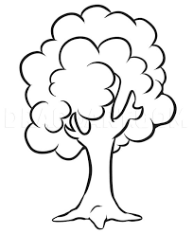

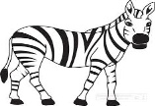



7. Colour the picture. [5]
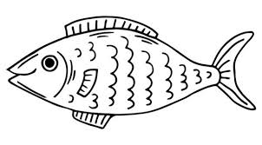



The End

